**Assignment 7.2**

**QN1 .Sales of different TV Task 6: Modify Sales of different TV Task 3 (refer session 5, assignment 2) to take advantage of Combiner. (Sales of different TV Task 3: Write a MapReduce program to calculate the total units sold in each state for Onida company**.**)**

**Sample file:**

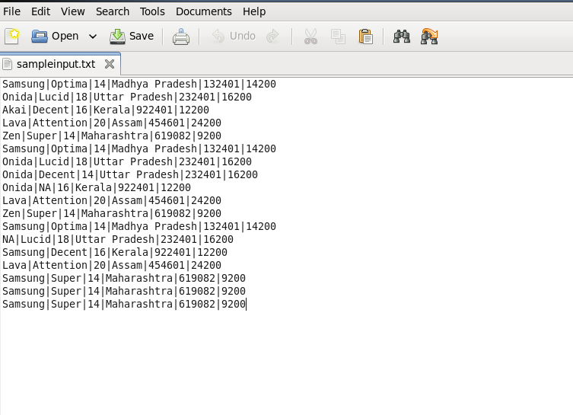

**DRIVER:**

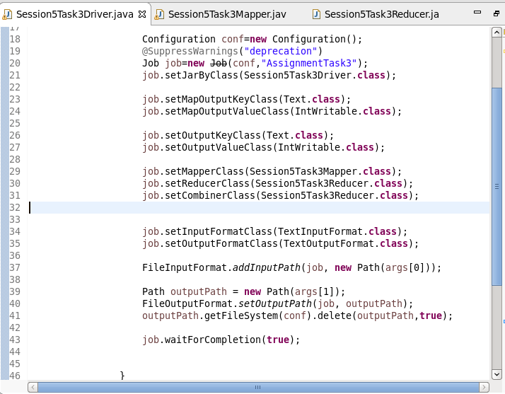

**MAPPER:**

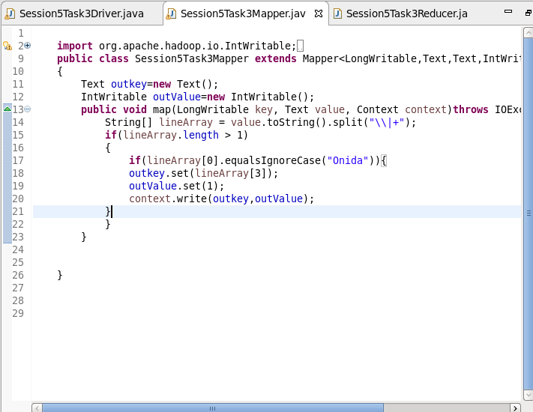

**REDUCER:**

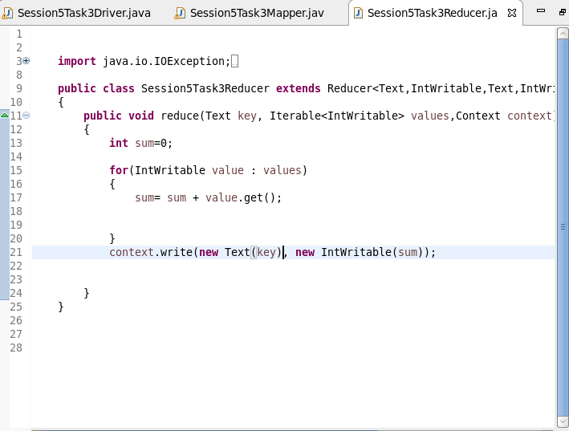

**RUNNING JAR**

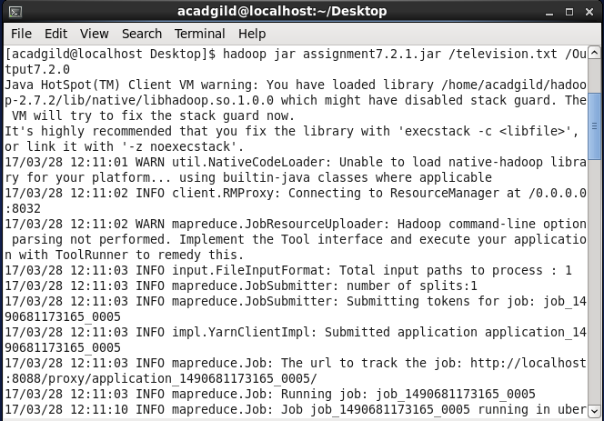

**Output:**

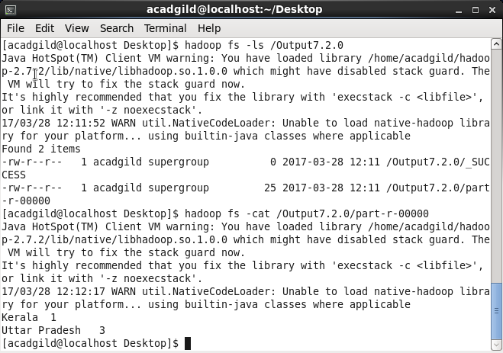

**2.** **Write a Mapreduce program to view the total sales for each product for every Company corresponding to each size. Make sure that all records for a single company goes to a single reducer and inside every reducer, keys must be sorted in descending order of the size. You may write a custom WritableComparable for this purpose.**

**Driver**

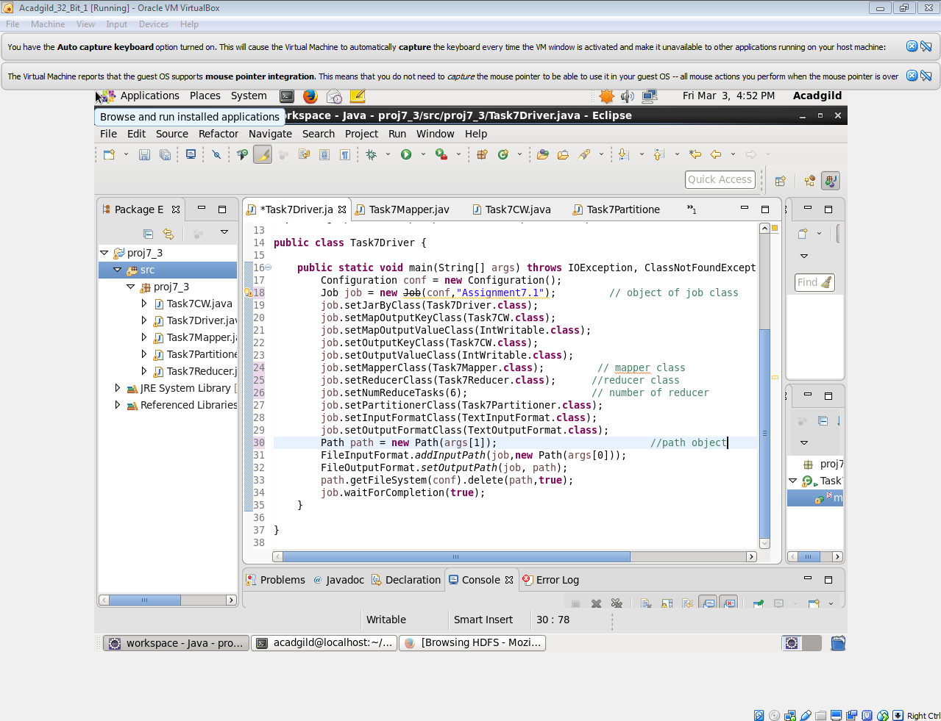

**MAPPER**

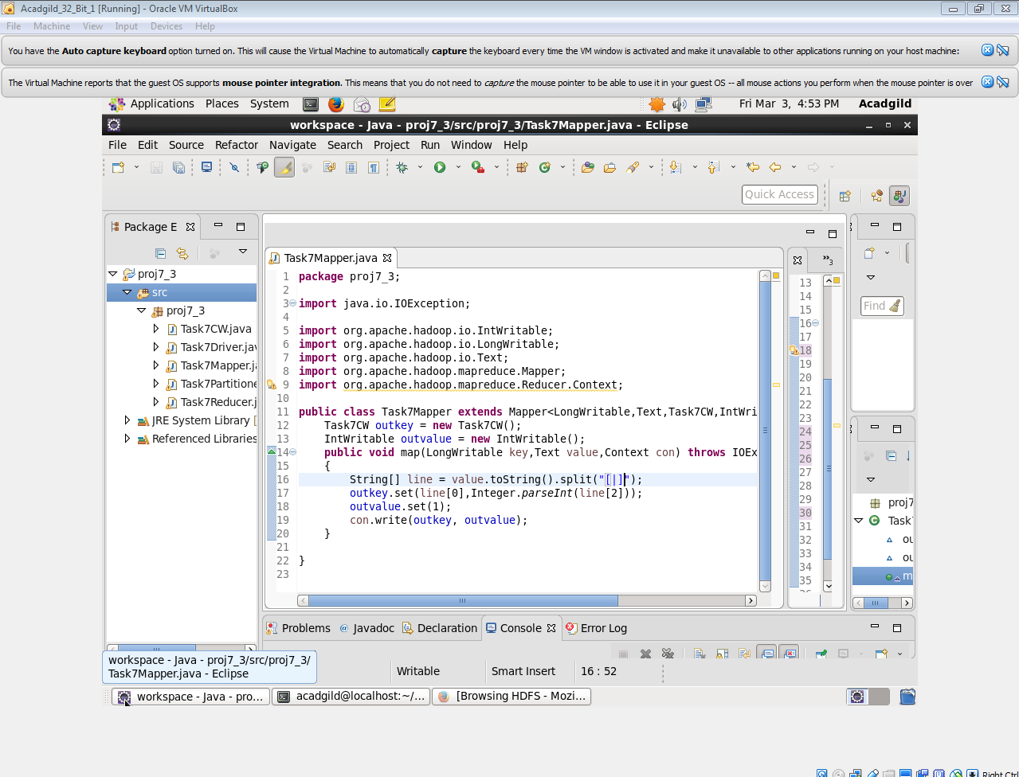

**REDUCER:**

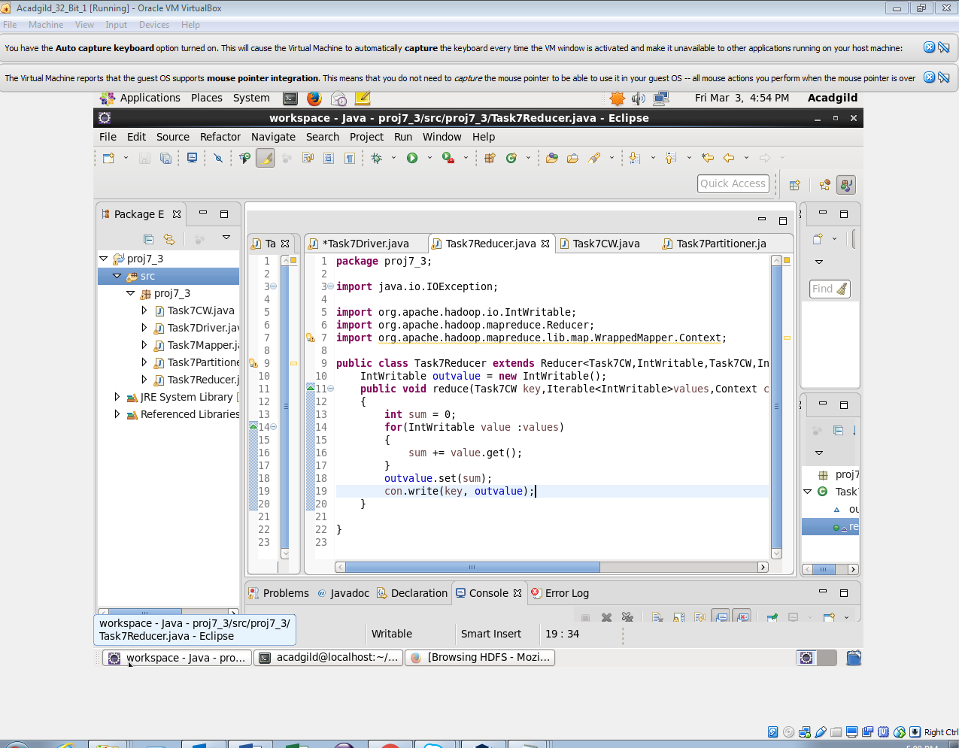

**PARTITIONER:**

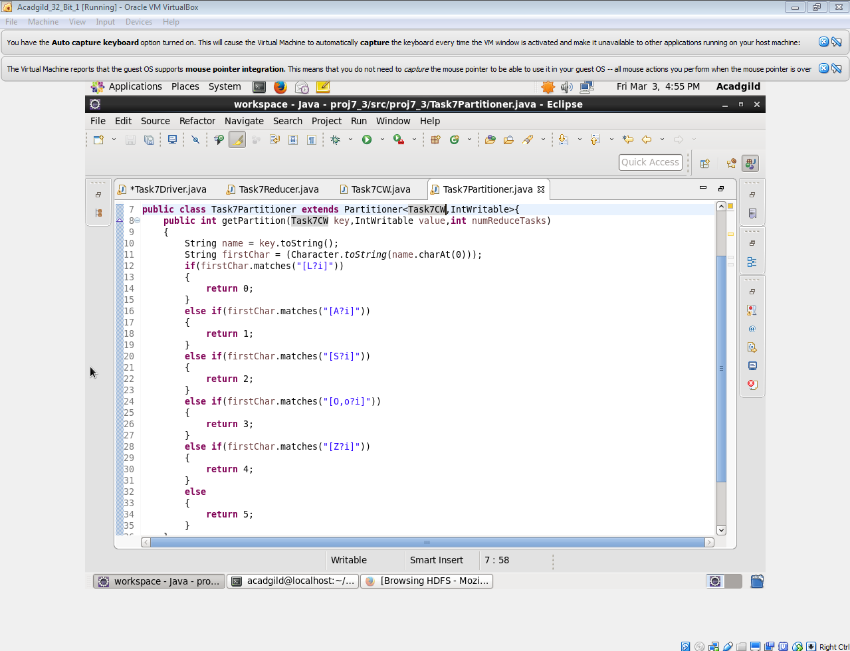

**COMPARABLE WRITABLE**

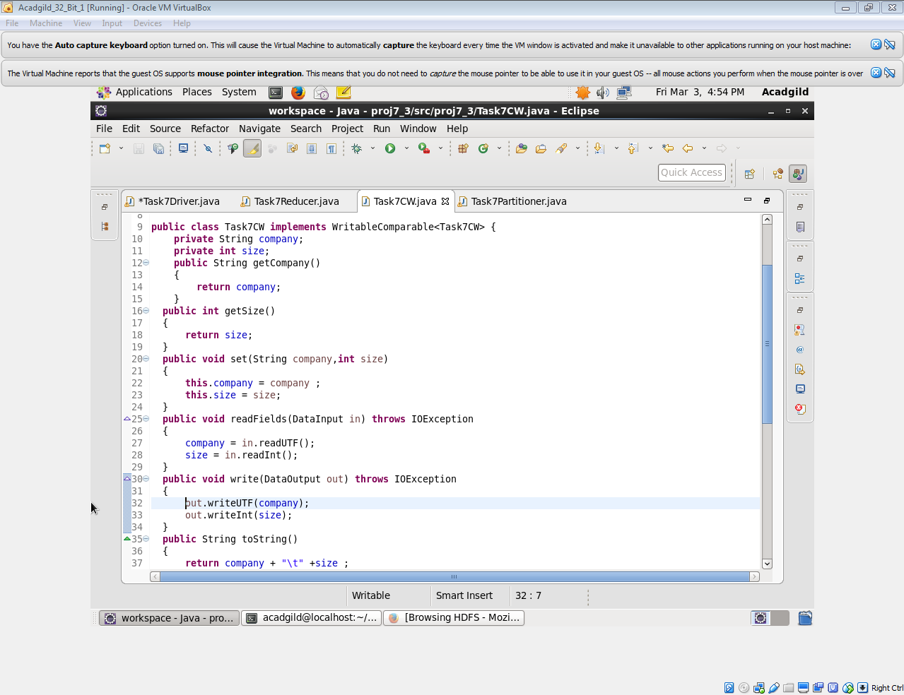

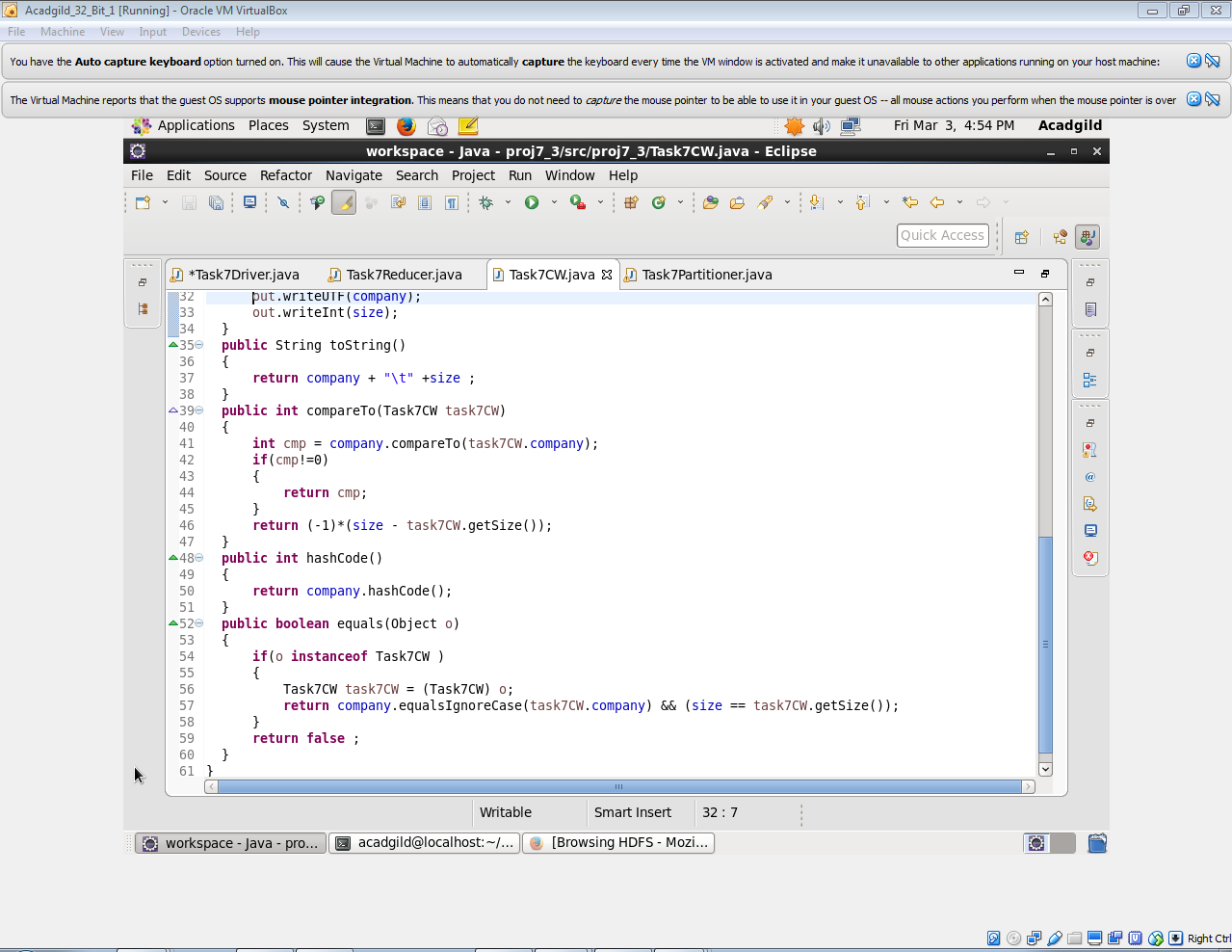

**Output:**

